Name: Aaron Debbink | Contact Info: akdebbink@gmail.com | Date: 11/15/2018

Lesson Title : Modeling Non-Ideal Batteries, Testing and Construction | Unit #: 1 | Lesson #:  2 | Activity #:  4
Activity Title: Battery Evaluation Design

Estimated Lesson Duration: | 10 days
Estimated Activity Duration: | 5 days

Setting: | Indian Hill High School, Room 118

Activity Objectives:

- The students will be able to create a procedure to test used lithium-ion cells.
- The students will be able to experimentally estimate the amount of usable capacity left a battery.
- The students will be able to experimentally estimate the internal resistance of a battery.
- The students will be able to refine a procedure to test used lithium-ion cells.
- The students will be able to formally present their refined procedure to test used lithium-ion cells.

Activity Guiding Questions:

- How can we determine the amount of electric charge stored in a battery?
- How can we measure the internal resistance of a battery?
- How can individual battery cells be tested in old battery packs?
- What are the quickest ways to determine if a lithium-ion battery cell has more usable life?
- What are the most reliable ways to determine if a lithium-ion battery cell has more usable life?

Next Generation Science Standards (NGSS)
Science and Engineering Practices (Check all that apply) | Crosscutting Concepts (Check all that apply)
☐ Asking questions (for science) and defining problems (for engineering) | ☐ Patterns
☐ Developing and using models | ☐ Cause and effect
☐ Planning and carrying out investigations | ☐ Scale, proportion, and quantity
☐ Analyzing and interpreting data | ☐ Systems and system models
☐ Using mathematics and computational thinking | ☐ Energy and matter: Flows, cycles, and conservation
☐ Constructing explanations (for science) and designing solutions (for engineering) | ☐ Structure and function.
☐ Engaging in argument from evidence | ☐ Stability and change.
☐ Obtaining, evaluating, and communicating information

Ohio’s Learning Standards for Science (OLS)
Expectations for Learning - Cognitive Demands (Check all that apply)
☐ Designing Technological/Engineering Solutions Using Science concepts (T)
☐ Demonstrating Science Knowledge (D)
☐ Interpreting and Communicating Science Concepts (C)
☐ Recalling Accurate Science (R)

Ohio’s Learning Standards for Math (OLS) and/or
Common Core State Standards -- Mathematics (CCSS)
Standards for Mathematical Practice (Check all that apply)
☐ Make sense of problems and persevere in solving them | ☐ Use appropriate tools strategically
☐ Reason abstractly and quantitatively | ☐ Attend to precision
☐ Construct viable arguments and critique the reasoning of others | ☐ Look for and make use of structure
☐ Model with mathematics | ☐ Look for and express regularity in repeated reasoning

Unit Academic Standards (NGSS, OLS and/or CCSS):

- 5.B.9.7: The student is able to refine and analyze a scientific question for an experiment using Kirchhoff’s Loop rule for circuits that includes determination of internal resistance of the battery and analysis of a non-ohmic resistor. [SP 4.1, 4.2, 5.1, 5.3]

Materials: (Link Handouts, Power Points, Resources, Websites, Supplies)

- Used lithium-ion battery packs – if you ask around enough you should be able to acquire used laptop or power tool batteries or they can be purchased in bulk from eBay
- Security Bit Set – this may be needed if opening power tool batteries.
- Zanflare C4 Smart Charger / Tester – This will be used to initially charge the individual lithium-ion cells once removed from the battery packs, before tested by students.
- 18650 Battery Cell Connectors - these are used to make electrical connections to the terminals of the individual lithium-ion cells.
  - abcGoodefg 1Slotx3.7V 18650 Battery Holder Case Plastic Battery Storage Box with Pin 10 Pack (10 Pcs 1 Solts) – these are the cheapest option, but will require soldered connections for testing.
  - Vruzend Solderless Connectors – these snap-on connectors use a bolt and nut to make the electrical connection to an external circuit without the need of soldering for testing or spot welding for making the final battery back.

- 1.2.4d Lithium Ion Batteries_Design Requirements
- 1.2.4e Lithium Ion Batteries_Presentation RUBRIC

Teacher Advance Preparation:

- You will need to obtain used laptop and / or power tool battery backs and safely disassemble them for students to test the individual lithium-ion cells. Each lab group will need at least 3 individual lithium-ion cells which came from the same battery pack. Watch the video below which shows how to disassemble a laptop battery to retrieve the individual lithium-ion cells. If you will be disassembling lithium-ion battery packs from power tools you may need to use a Security Bit Set.
  - Video: How to open Laptop Battery without destroying it | How to get 18650 Battery from laptop battery
- Use a wire cutter to cut any wires connected to the cells from any circuit boards. SAFETY: Only cut 1 wire at a time.
- Use needle nose plyers to remove the metal strips connecting the individual cells. SAFTEY: Be careful to only touch one battery terminal at a time with the plyers. Watch out for shorts!
- A small grinding wheel may be needed to finish removing the spot welds from the ends of the cylindrical cells.
- The individual cells will need to be initially charged with a lithium-ion cell charger before tested by students. SAFTEY: Use only a battery charger which is designed to charge lithium-ion batteries.
  - I would recommend using the Zanflare C4 Smart Charger / Tester.
- Label and place the individual cylindrical cells from each battery pack in a separate zip lock bag. Each lab group will receive one bag for testing. The following is a suggested naming convention.
  - “P1A” – Power tool battery, battery pack #1, battery A
  - “L3B” – Laptop battery, battery pack #3, battery B.
  - The following image shows how the cells were labeled which came from the 1st disassembled battery pack from a power tool.
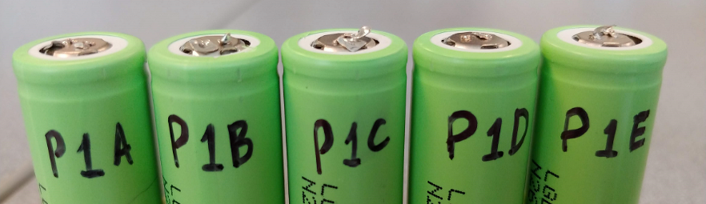

Activity Procedures:

Day 1

- Handout the Battery Testing Documentation Requirements (1.2.4d Lithium Ion Batteries_Design Requirements) and discuss the naming convention, sharing requirements, formatting, and general overview of the required sections.
  - The student will be creating a Google Doc to document their testing process, data collection and revisions throughout the activity. This documentation will be graded and will also be used by each lab group to help create a presentation of their design process and overall conclusions.

- Explain section #1 and #2 in detail. The students will be required to complete these sections before testing individual lithium-ion cells. See below for section #1 and section #2 requirements.
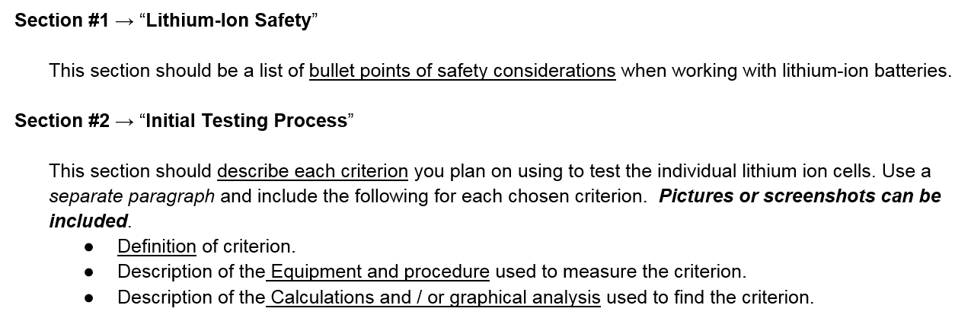

- Students will use the remainder of the period completing sections #1 and #2. This will be homework if not completed in class.

- Check section #1 and #2 for any group which finishes during class time. Hand out a bag of lithium-ion cells to each lab group once the sections are approved.
  - The individual cells should be kept in the classroom during the project in case students are absent.

Day 2

- Check section #1 and #2 from the remaining lab groups. Hand out a bag of lithium-ion cells to each lab group once the sections are approved.

- The students should test 1 or 2 cells using their initial testing criteria and record the data and analysis in their Google Doc. See below for section #3 requirements.

- Each student group should prepare a large whiteboard to give a progress report to the class. The progress report should include initial testing criteria, procedures, and preliminary data to be shared with the class at the beginning of the next class period.

Day 3

- Have each lab group share their progress report with the class. Allow time for questions.

- Give students time to consider their initial process and their peers’ progress reports. Students should refine their battery testing process by either adding or removing testing criteria or modifying a testing procedure for one of the initial criterion. The explanation of any revisions should be included in section #4 in the Google Doc. The final revised testing process should be documented in section #5. See below for section #4 and section #5 requirements.
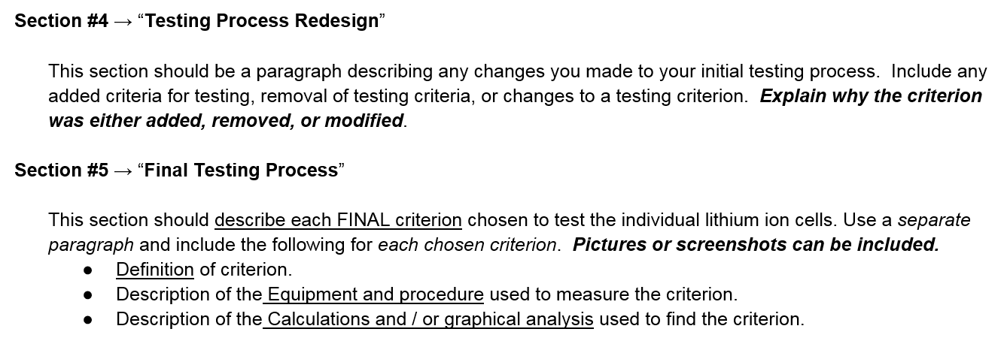

- Students should continue testing at least 2 additional cells with their revised testing process. The data and analysis should be documented in section #6 on their Google Doc. See below for section #6 requirements.

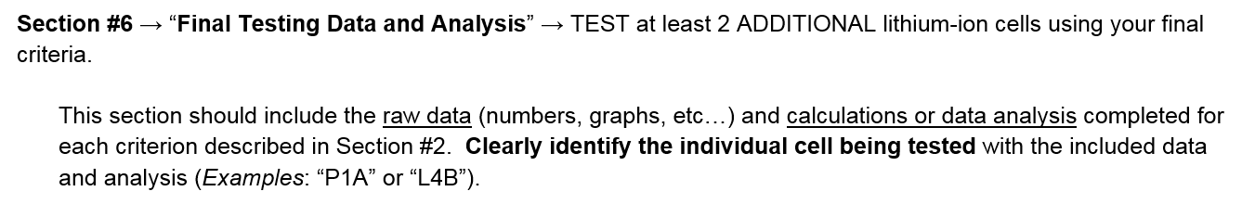

Day 4

- Discuss with the students that they will be presenting their design process for battery evaluation to the class. Handout and discuss the presentation grading rubric (1.2.4e Lithium Ion Batteries_Presentation RUBRIC). This discussion could also happen on day 3 so students can work on the presentation during any wait time while battery testing.

- Students should finish testing 2 or more additional cells using their final testing process. The data and analysis should be documented in section #6 on their Google Doc.

  - The students should work on the presentation during any wait time while battery testing.
Day 5

- Students present their design process for battery evaluation using a Google Slides file.
  - Use the presentation rubric for grading. (1.2.4e Lithium Ion Batteries_Presentation RUBRIC)

Formative Assessments: Link the items in the Activities that will be used as formative assessments.

This activity provides many opportunities for the teacher to formatively assess the students’ knowledge about batteries, energy storage, and internal resistance. The teacher is able to walk around the classroom and passively observe while students are designing and evaluating their battery testing process. The teacher can also actively ask questions to probe for understanding. The students will also be verbally sharing their ideas with the class both informally and formally. This will provide additional opportunities for the teacher to formatively assess the students’ knowledge about batteries, energy storage, and internal resistance.

Summative Assessments: These are optional; there may be summative assessments at the end of a set of Activities or only at the end of the entire Unit.

The engineering design process which is a part of this activity will be assessed with the grading rubric for the design presentation. See the following document.

- 1.2.4e Lithium Ion Batteries_Presentation RUBRIC
Differentiation: Describe how you modified parts of the Lesson to support the needs of different learners.
Refer to Activity Template for details.

This activity gives different types of learners an opportunity to interact with the ideas in different ways. Hands-on learners will get to physically construct a circuit and physically take measurements on that circuit. Visual learners will be able to identify with the physical circuits during experimentation, the whiteboard illustrations of data collection and analysis for each group, and the final presentations. Audible learners will benefit from the small and large group discussions during the entire design process. Regardless of learning style preference, all learners will benefit from having the information presented in various ways.

The nature of small group, collaborate work allows students who need more guidance to receive it. In small collaborate groups, the first place that students often receive help is from their peers. The teacher can also walk around listening to the student discussions and ask probing questions to help guide students toward a correct understanding. This allows the teacher to see where students are struggling and need extra guidance or help.

Reflection: Reflect upon the successes and shortcomings of the lesson.

Nearly all student groups were able to identify that they wanted to measure the “capacity” of the battery, but needed help thinking through an experimental procedure to measure the capacity. With each class, when a critical mass of groups was thinking about how to experimentally measure the battery’s capacity, I facilitated a whole class discussion which helped them determine a procedure. The discussion started by having students identify that the capacity of a battery is another way of saying how much electric charge a fully charged battery can transfer through a circuit, measured in Coulombs. Once students understood it was related to the electric charge stored, they were able to think through how measuring the current over a time interval would allow them to calculate the charge. The students decided to discharge the battery and measure the current, then take the integral, or find the area, on a current versus time graph. This area would be the electric charge which came from the battery which would allow them to make an inference about the capacity.

It was fun to see the different testing procedures each group chose. The different testing procedures included measuring the cell’s capacity, ability to supply high current, terminal voltage after charging, and internal resistance. They students also communicated that they enjoyed being able to develop their own testing procedures rather than being just given procedures to use.

The only groups that were not able to test more than a couple of their lithium-ion cells were those looking to estimate each cell’s capacity. This was due to the fact that it took at least 3 – 4 hours to fully discharge one cell while collecting data, and this process had to be monitored so the cell terminal voltage did not drop below the minimum 2.5 volts. Most groups chose to measure the batteries discharge capacity over a shorter time interval, rather than trying to find the battery’s total capacity.

